CO1_AT3_Visualization Design Exercise

Question 1
Question
A multinational retail company has collected annual sales information from its branches across
different regions. Using the given dataset, design an effective visualization that simultaneously
represents Sales, Profit, Number of Customers, Product Category, and Region. Select suitable
aesthetic mappings and apply an appropriate scale transformation wherever necessary. Justify
every visualization design choice.
R Dataset
retail <- data.frame(
Branch=c("B1","B2","B3","B4","B5","B6","B7","B8","B9","B10",
"B11","B12","B13","B14","B15","B16","B17","B18","B19","B20"),
Region=c("North","South","East","West","North","South","East","West",
"North","South","East","West","North","South","East","West",
"North","South","East","West"),
Category=c("Electronics","Furniture","Clothing","Food","Electronics",
"Furniture","Clothing","Food","Electronics","Furniture",
"Clothing","Food","Electronics","Furniture","Clothing",
"Food","Electronics","Furniture","Clothing","Food"),
Sales=c(450000,620000,180000,920000,350000,720000,250000,1080000,
560000,670000,195000,980000,430000,760000,280000,1150000,
510000,690000,220000,1250000),
Profit=c(45000,95000,-12000,185000,25000,120000,18000,225000,
72000,98000,-8000,205000,51000,132000,24000,250000,
69000,115000,15000,285000),
Customers=c(1200,2500,980,4200,1800,3000,1250,5200,
2100,3300,1100,4700,1750,3600,1450,5600,
2200,3900,1600,6100)

)
Code:
library(ggplot2)
library(scales)

retail <- data.frame(
Branch=c("B1","B2","B3","B4","B5","B6","B7","B8","B9","B10",
"B11","B12","B13","B14","B15","B16","B17","B18","B19","B20"),
Region=c("North","South","East","West","North","South","East","West",
"North","South","East","West","North","South","East","West",
"North","South","East","West"),
Category=c("Electronics","Furniture","Clothing","Food","Electronics",
"Furniture","Clothing","Food","Electronics","Furniture",
"Clothing","Food","Electronics","Furniture","Clothing",
"Food","Electronics","Furniture","Clothing","Food"),
Sales=c(450000,620000,180000,920000,350000,720000,250000,1080000,
560000,670000,195000,980000,430000,760000,280000,1150000,
510000,690000,220000,1250000),
Profit=c(45000,95000,-12000,185000,25000,120000,18000,225000,
72000,98000,-8000,205000,51000,132000,24000,250000,
69000,115000,15000,285000),
Customers=c(1200,2500,980,4200,1800,3000,1250,5200,
2100,3300,1100,4700,1750,3600,1450,5600,
2200,3900,1600,6100)
)

ggplot(retail,
aes(x=Sales,
y=Profit,
size=Customers,
colour=Category,
shape=Region))+
geom_point(alpha=0.8)+
scale_x_log10(labels=comma)+
labs(title="Retail Sales Analysis",
x="Sales (Log Scale)",
y="Profit",
size="Customers")+
theme_minimal()
output:
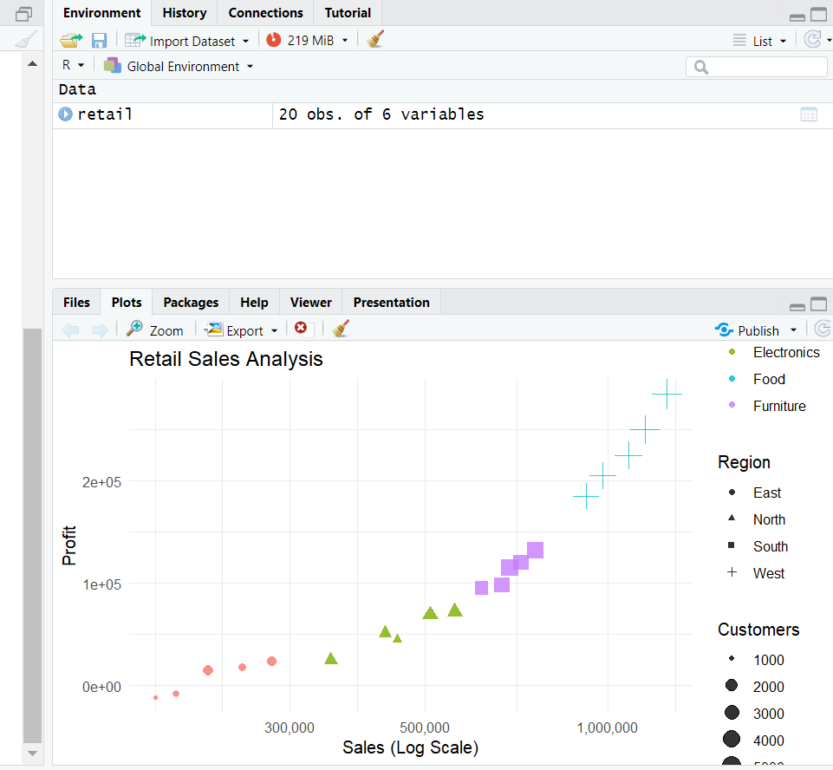

Question 2
Question
The following dataset contains monthly electricity generation from different energy sources.
Develop visualizations using Cartesian Coordinates and Polar Coordinates. Compare both
visualizations and determine which coordinate system provides better analytical insight.
Explain your design decisions.
R Dataset
energy <- data.frame(
Month=month.abb,
Coal=c(620,580,590,605,640,670,690,720,700,680,650,630),
Gas=c(310,295,305,320,340,355,360,370,365,350,335,320),
Solar=c(45,60,90,130,180,230,250,245,210,160,90,50),
Wind=c(80,95,120,150,170,185,195,190,175,150,110,90),
Hydro=c(140,150,160,170,180,195,205,210,200,185,165,150)
)
Code:
library(ggplot2)

energy <- data.frame(
Month=month.abb,
Coal=c(620,580,590,605,640,670,690,720,700,680,650,630),
Gas=c(310,295,305,320,340,355,360,370,365,350,335,320),
Solar=c(45,60,90,130,180,230,250,245,210,160,90,50),
Wind=c(80,95,120,150,170,185,195,190,175,150,110,90),
Hydro=c(140,150,160,170,180,195,205,210,200,185,165,150)
)

energy_long <- data.frame(
Month=rep(energy$Month,5),
Source=rep(c("Coal","Gas","Solar","Wind","Hydro"),
each=12),
Generation=c(energy$Coal,
energy$Gas,
energy$Solar,
energy$Wind,
energy$Hydro)
)

ggplot(energy_long,
aes(Month,Generation,
group=Source,
colour=Source))+
geom_line(size=1.2)+
geom_point(size=2)+
labs(title="Monthly Electricity Generation")+
theme_minimal()
Output:
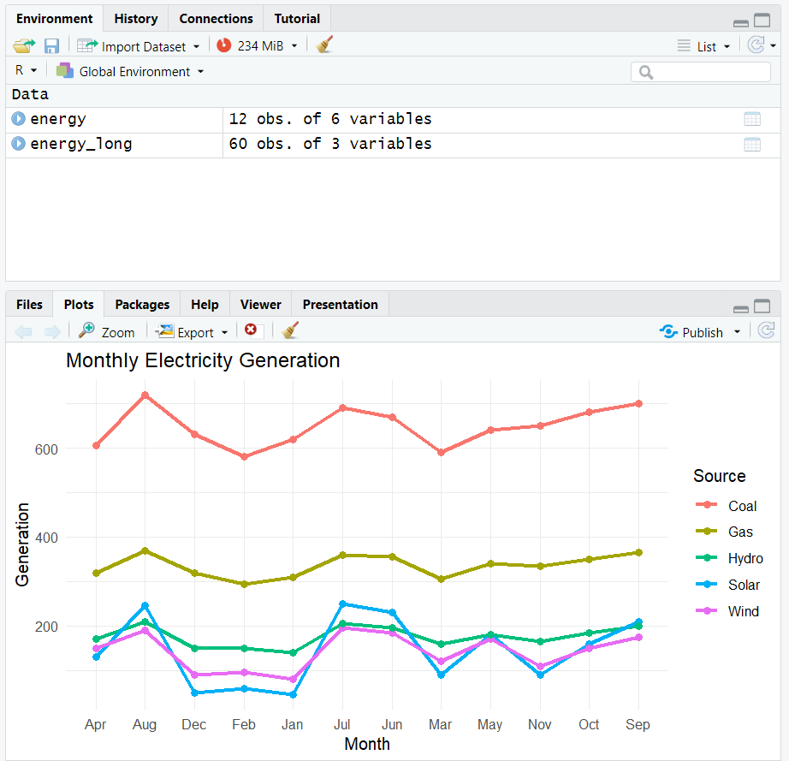

Question 3
Question
An environmental monitoring agency has collected climate data from major Indian cities.
Design a visualization that effectively represents Temperature, Air Quality Index (AQI),
Rainfall, and Humidity using appropriate colour scales. Select a suitable colour palette and
justify its effectiveness for accurate interpretation and accessibility.
R Dataset
climate <- data.frame(
City=c("Delhi","Mumbai","Chennai","Kolkata","Hyderabad",
"Bangalore","Pune","Ahmedabad","Jaipur","Lucknow",
"Bhopal","Patna","Goa","Kochi","Nagpur","Indore",
"Surat","Visakhapatnam","Coimbatore","Mysuru"),

Temperature=c(44,35,38,40,39,31,33,43,45,39,
38,40,32,30,41,37,36,34,29,28),
Humidity=c(22,84,78,72,48,66,58,26,18,42,
36,45,89,91,30,34,76,82,68,64),
Rainfall=c(6,280,220,190,85,120,95,2,1,35,
48,72,360,410,12,20,180,240,130,145),
AQI=c(365,110,125,180,160,72,84,290,320,240,
175,220,58,52,270,190,145,98,60,55)
)
Code:
library(ggplot2)
library(viridis)

climate <- data.frame(
City=c("Delhi","Mumbai","Chennai","Kolkata","Hyderabad",
"Bangalore","Pune","Ahmedabad","Jaipur","Lucknow",
"Bhopal","Patna","Goa","Kochi","Nagpur","Indore",
"Surat","Visakhapatnam","Coimbatore","Mysuru"),

Temperature=c(44,35,38,40,39,31,33,43,45,39,
38,40,32,30,41,37,36,34,29,28),
Humidity=c(22,84,78,72,48,66,58,26,18,42,
36,45,89,91,30,34,76,82,68,64),
Rainfall=c(6,280,220,190,85,120,95,2,1,35,
48,72,360,410,12,20,180,240,130,145),
AQI=c(365,110,125,180,160,72,84,290,320,240,
175,220,58,52,270,190,145,98,60,55)
)

ggplot(climate,
aes(x=Temperature,
y=AQI,
size=Rainfall,
colour=Humidity))+
geom_point(alpha=0.8)+
scale_colour_viridis_c(option="plasma")+
labs(title="Climate Analysis of Indian Cities",
x="Temperature",
y="AQI")+
theme_minimal()
Output:
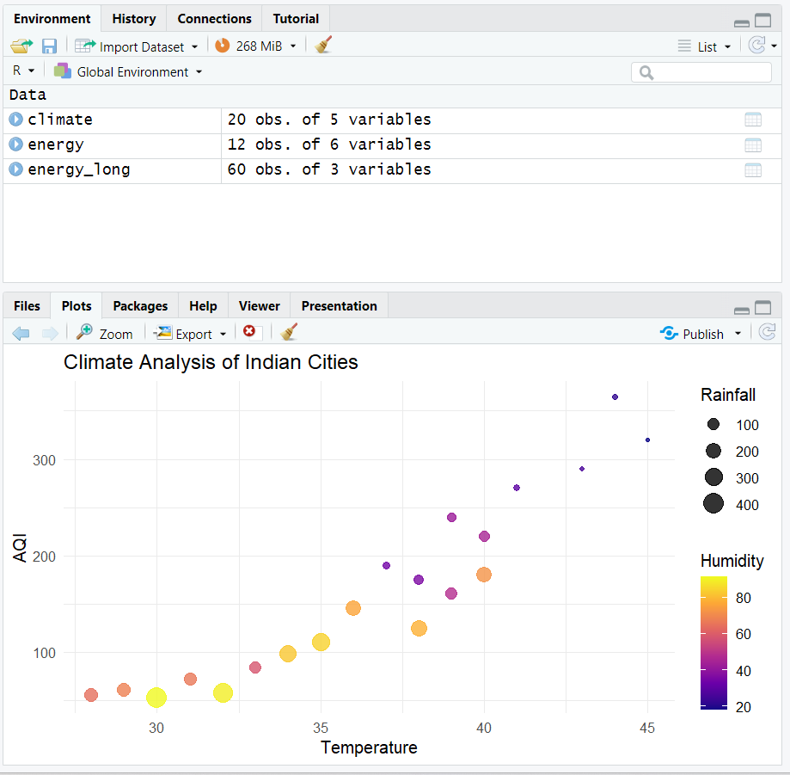

Question 4
Question
A software company has recorded project statistics for twenty software development teams.
Design a visualization that requires the use of a nonlinear axis transformation to represent
highly skewed data. Justify the selected transformation and explain how it improves
interpretation over a linear scale.
R Dataset
software <- data.frame(
Team=paste("T",1:20,sep=""),
LinesOfCode=c(12000,18000,25000,35000,48000,
62000,81000,96000,120000,150000,
185000,240000,310000,390000,480000,
620000,810000,1050000,1350000,1800000),
Bugs=c(35,52,60,72,88,
110,125,142,165,188,
205,240,280,320,365,
420,490,560,640,720),
Developers=c(5,7,9,10,12,
14,16,18,20,22,

25,28,30,34,38,
42,46,50,55,60),
Complexity=c(2.1,2.4,2.7,3.0,3.2,
3.5,3.8,4.1,4.5,4.8,
5.1,5.4,5.8,6.2,6.6,
7.1,7.6,8.0,8.5,9.0)
)
Code:
library(ggplot2)
library(scales)

software <- data.frame(
Team=paste("T",1:20,sep=""),
LinesOfCode=c(12000,18000,25000,35000,48000,
62000,81000,96000,120000,150000,
185000,240000,310000,390000,480000,
620000,810000,1050000,1350000,1800000),
Bugs=c(35,52,60,72,88,
110,125,142,165,188,
205,240,280,320,365,
420,490,560,640,720),
Developers=c(5,7,9,10,12,
14,16,18,20,22,
25,28,30,34,38,
42,46,50,55,60),
Complexity=c(2.1,2.4,2.7,3.0,3.2,
3.5,3.8,4.1,4.5,4.8,
5.1,5.4,5.8,6.2,6.6,
7.1,7.6,8.0,8.5,9.0)
)

ggplot(software,
aes(x=LinesOfCode,
y=Bugs,
size=Developers,
colour=Complexity))+
geom_point(alpha=0.8)+
scale_x_log10(labels=comma)+
scale_colour_viridis_c()+
labs(title="Software Project Statistics",
x="Lines of Code (Log Scale)",
y="Number of Bugs")+
theme_minimal()
Output:
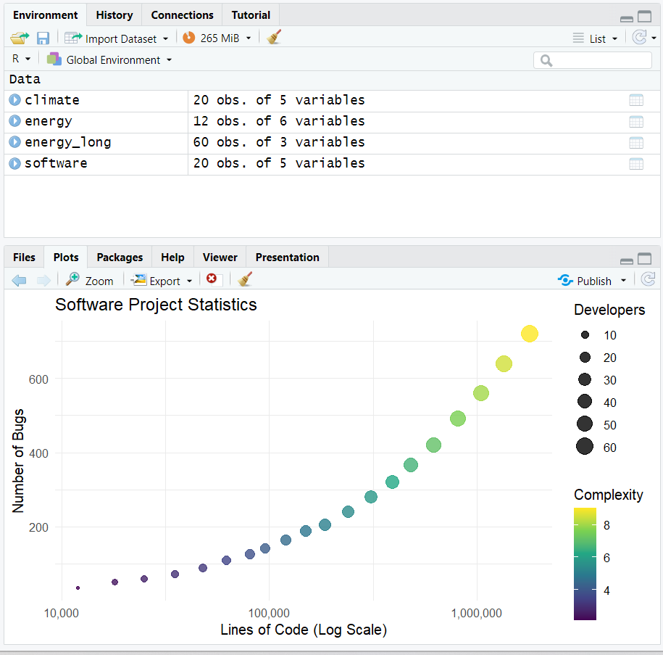

Question 5
Question
A financial analytics company has collected performance data for twenty publicly listed
companies. Develop an integrated visualization that effectively communicates Revenue, Profit
Margin, Market Capitalization, Employee Strength, and Industry Sector. Use appropriate
aesthetic mappings, coordinate systems, scales, and colour palettes to maximise
interpretability while minimising perceptual bias.
R Dataset
companies <- data.frame(
Company=paste("C",1:20,sep=""),
Sector=c("IT","Banking","Healthcare","Retail","Energy",
"IT","Banking","Healthcare","Retail","Energy",
"IT","Banking","Healthcare","Retail","Energy",
"IT","Banking","Healthcare","Retail","Energy"),
Revenue=c(420,580,720,850,980,
1150,1320,1480,1650,1820,
2050,2280,2550,2840,3150,
3480,3860,4250,4680,5200),
ProfitMargin=c(8.2,15.6,11.4,9.3,18.5,
20.4,17.8,14.2,10.5,22.1,
24.5,19.8,16.7,13.4,26.2,

28.1,21.5,18.3,15.2,30.4),
Employees=c(1500,3200,2100,4200,2800,
5100,6800,3900,7200,4500,
8100,9500,6200,10300,7200,
11800,13200,8600,14500,16000),
MarketCap=c(8500,12000,9800,7600,14500,
18200,21500,16800,13200,24500,
28500,32500,24800,19200,38200,
42500,46800,35600,29800,52000)
Code:
library(ggplot2)
library(viridis)

companies <- data.frame(
Company=paste("C",1:20,sep=""),
Sector=c("IT","Banking","Healthcare","Retail","Energy",
"IT","Banking","Healthcare","Retail","Energy",
"IT","Banking","Healthcare","Retail","Energy",
"IT","Banking","Healthcare","Retail","Energy"),
Revenue=c(420,580,720,850,980,
1150,1320,1480,1650,1820,
2050,2280,2550,2840,3150,
3480,3860,4250,4680,5200),
ProfitMargin=c(8.2,15.6,11.4,9.3,18.5,
20.4,17.8,14.2,10.5,22.1,
24.5,19.8,16.7,13.4,26.2,
28.1,21.5,18.3,15.2,30.4),
Employees=c(1500,3200,2100,4200,2800,
5100,6800,3900,7200,4500,
8100,9500,6200,10300,7200,
11800,13200,8600,14500,16000),
MarketCap=c(8500,12000,9800,7600,14500,
18200,21500,16800,13200,24500,
28500,32500,24800,19200,38200,
42500,46800,35600,29800,52000)
)

ggplot(companies,
aes(x=Revenue,
y=ProfitMargin,
size=MarketCap,
colour=Sector))+
geom_point(alpha=0.8)+
scale_size_continuous(range=c(3,12))+
scale_colour_viridis_d()+
labs(title="Financial Performance of Companies",
x="Revenue",
y="Profit Margin (%)",
size="Market Cap")+
theme_minimal()
Output:
